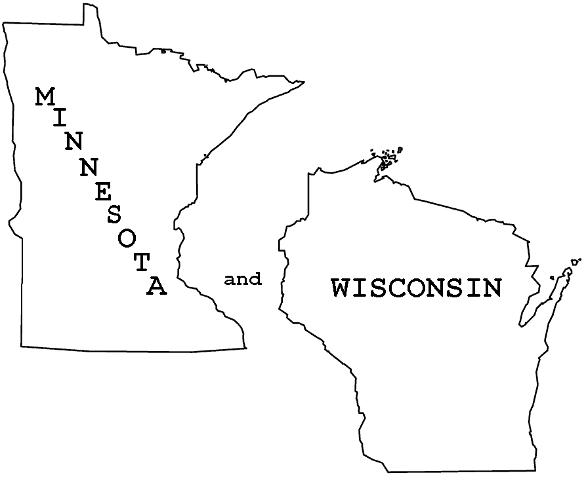
2023 Minnesota/Wisconsin
RIDE SCHEDULE
Ride schedule changes and adjustments occur throughout the season. Be sure to verify dates and locations with ride manager
and/or ride flyer and the website (www.nacmo.org).
For any questions about an individual ride, please contact the ride manager.
Weekend dates | Location | Ride Manager(s) | Contact info
May 13-14 | Sand Dunes  Zimmerman MN | K-Klan  Jim Klein  Wendy Klein | wendyandjim@sherbtel.net  612-219-4235  612-518-8327
May 27-28-29  Memorial W/E | Hay Meadow  Bloomer WI | Posse Chicks  Allison Mentink  Liz Falkner | allisonmentink@yahoo.com  715-308-3602
June 10-11 | Volga River  Fayetteville IA | Team Iowa  Roland Newton  Norma Newton | Newtonrn2013@gmail.com  515-681-1725
June 24-25 | Eau Galle (Summer)  Spring Valley WI | Fun Guys  Tony Falkner | tfalkner@hotmail.com  715-928-2389
August 5-6 | Wildcat Mountain  Ontario WI  OR  TBD | Allison Mentink  Cindy Rasmussen | allisonmentink@yahoo.com  715-308-3602
August 19-20 | Adeline Green  Eleva WI | Tall Guys  Dan Wallery  John Swingle | Wallery@nwltd.com  715-533-0772
September 2-3 | Eau Galle (Fall)  Spring Valley WI | Deaux Lori-ans  Lori Elliott-Larson  Lori Books  Susan Sanders | Loranacres@outlook.com  715-448-2302
September 16-17 | Hay Creek  Redwing, MN  OR  Zumbro Bottoms  Theilman, MN | Austin Hegwood  Kip Gore | ahegwood@frontier.com  715-302-7279  kiplinggore@gmail.com
October 7-8 | Ox Lake Bible  Amery WI | Bushwhack  Lisa Kaiser  Pat Kopp  Linda Weber | chirolbk@gmail.com  651-338-2401
October 21-22 | Zumbro Bottoms  Theilman, MN | K-Klan  Clay Kraus  Marlys Kraus | C1T2K3@aol.com  507-272-2572

RIDE MANAGERS: Be sure to use the current membership forms, ride registrations, and insurance waiver from www.nacmo.org. Each member needs to sign the insurance waiver one time each ride season. If you need to cancel or change a date or location of a ride, it is very important to let Jim Klein know as soon as that decision is made.

Be SURE to print and have available a current membership list. In addition to having membership, team, and horse numbers available, it will show if there is a current signed waiver for the year.

