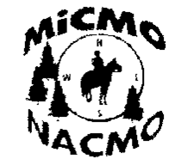
NATIONAL ASSOCIAITON OF
MAIL TO:
MiCMO
DEB SCHROCK
3127 22ND ST
HOPKINS, MI 49328
COMPETITIVE MOUNTED
ORIENTEERING

RIDE SANCTION REQUEST:

Name of Ride: ______________________________________________________
Location: _________________________________________________________
Date of Rides: _______________________________________________________
Ride Manager: _________________________________NACMO # ____________
Address: ___________________________________________________________
City: ____________________________________ State: ______ Zip: ___________
Phone: __________________________ Fax: ______________________________
Email: _____________________________________________________________
Co-Ride Manager: _______________________________NACMO # ____________

All persons managing or assisting or riding in a CMO must be either annual members or day members. The ride manager must be an annual CMO member. Enclosed is $5.00 per ride date payable 30 days before ride.

I have read, and understand, and I agree to abide by all rules and release NACMO from any and all liabilities.

Signature of Ride Manager: ____________________________ Date: __________

Ride Manager forms and instructions are at the website www.nacmo.org. Follow the “for MEMBERS” tab.

